**Setting up Hadoop project in eclipse.**

**1. Creating a java project using the below link**

## **https://www.youtube.com/watch?v=U5yhJiFRL38**

**2.** .Add the below list of jars from the share folder (hadoop-2.10.0\share) to your build path(one project properties you will find build path option) to resolve compilation

dependencies

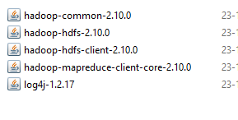

Note:

use Apache 2.10 hadoop distribution library

https://archive.apache.org/dist/hadoop/common/hadoop-2.10.0/hadoop-2.10.0.tar.gz

3. Development of MR Job

Create the driver,mapper and reducer code using java. If there are no compilation proceed with packaging

4. create the jar using the export command.

https://www.youtube.com/watch?v=jDDYSdgNf9Q